ULTRASONIC TESTING REPORT
Company/Client |  | NCOC N. V. |  | Project |  | ESKENE WEST |  | Location |  | Oil Tr-2
Line No/Tag No: |  | A1-2102-RO-130-3”-A13-WN |  | Material |  | A333 Gr.6 SMLS |  | Día × Nominal Thickness |  | 3’’x5.49mm
Procedure No: |  | QP-11-UTT-Q01 Rev 03  GOST 28702-90 |  | Calibration Block |  | Step wedge |  | Probe  S/N |  | D7906  1171297
 |  |  |  | Calibration block Range |  | 2.50-12.50 mm |  | Angle |  | 0º
Manufacturing Code |  | ASME B31.3 |  | Calibration Temp |  | +1ºC |  | Frequency |  | 5 MHz
 |  |  |  | Object Temp |  | +1ºC |  | Size |  | 11 mm
Acceptance Standard: |  | Acc. to the client specif. |  | Correction factors |  | n/a |  | Crystal |  | Dual
Surface condition |  | Coated |  | Couplant |  | UT Gel |  | Accuracy |  | ± 0,1 mm
S. No | Equipment/  Material Name |  | Manufacturer |  | Serial No |  | Calibration certificate No |  | Calibration Expiry date
 | DL-38 |  | OLYMPUS |  | 171421601 |  | BK-01-0674 |  | 20-03-2020
 | Step calibration block 2214M |  | OLYMPUS |  | 026519 |  | - |  | -
Job description:

- UT spot check performed on disulphide line A1-2102-RO-130-3”-A13-WN (drawing No KE01-A1-210-PO-P-DI-8115-053).
- Inspection performed on East, West, South, North, Top, Bottom and Extrados from external.
- Echo to echo UT technique was used.
Notes:
N/A – not applicable.

Inspection drawing
A1-2102-RO-130-3”-A13-WN
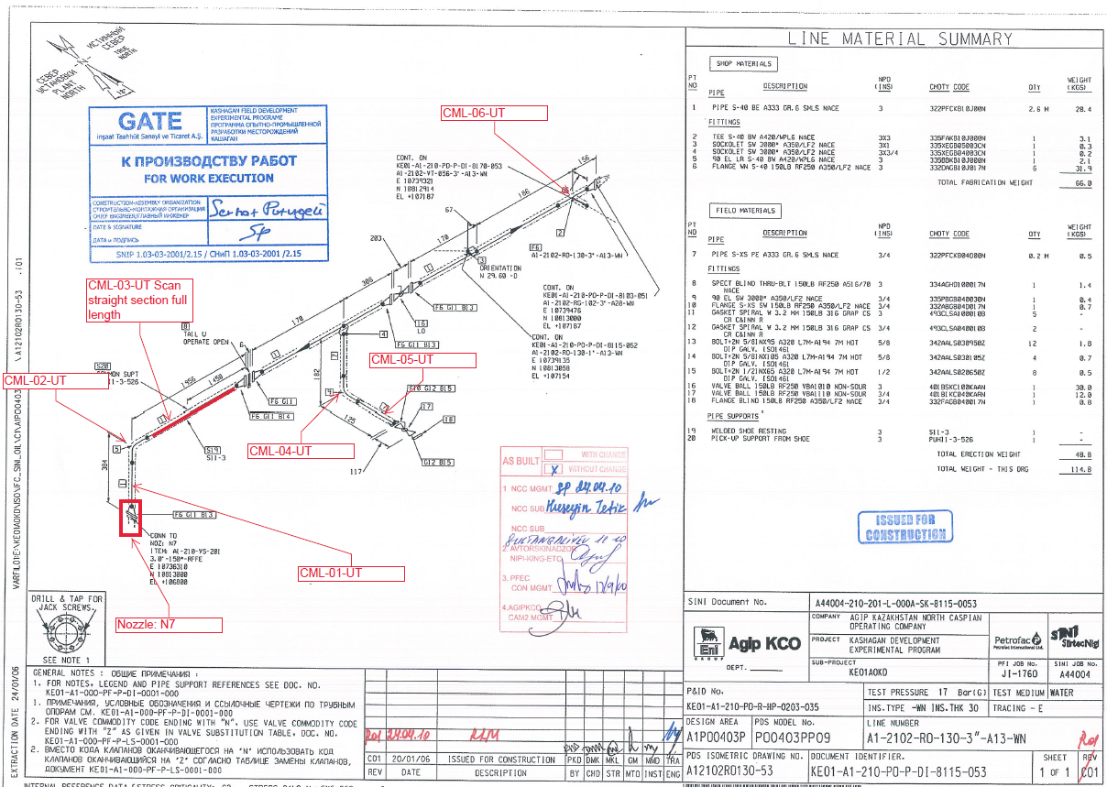

Inspection results
S/NO | Location | Item description | Spot check  Location | DIA(Ø), inch | Nominal thickness, mm | Top  mm | Bottom  mm | East  mm | West  mm | South  mm | North  mm | Extrados mm
1 | N7 | Nozzle | 1 | 3 | 15.24 | - | - | 15.16 | 15.38 | 15.31 | 15.02 | -
2 | CML-01 | Pipe | 1 | 3 | 5.49 | - | - | 5.71 | 5.60 | 5.15 | 5.52 | -
3 | CML-02 | Elbow | 1 | 3 | 5.49 | - | - | - | - | 4.81 | 4.98 | 4.35
4 | CML-04 | Elbow | 1 | ¾ | 3.91 | - | - | 6.17 | 6.29 | - | - | 5.92
5 | CML-05 | Pipe | 1 | ¾ | 3.91 | 3.92 | 3.73 | 3.91 | 3.84 | - | - | -

Inspection results
S/NO | Location | Item description | Spot check  Location | DIA(Ø), inch | Nominal thickness, mm | Top  mm | Bottom  mm | East  mm | West  mm | South  mm | North  mm | Extrados mm
6 | CML-03 | Pipe | 0 | 3 | 5.49 | 5.34 | 5.27 | - | - | 5.32 | 5.33 | -
7 | CML-03 | Pipe | 50 | 3 | 5.49 | 5.16 | 5.21 |  |  | 5.27 | 5.30
8 | CML-03 | Pipe | 100 | 3 | 5.49 | 5.12 | 5.29 | - | - | 5.20 | 5.28 | -
9 | CML-03 | Pipe | 150 | 3 | 5.49 | 5.05 | 5.16 | - | - | 5.16 | 5.23 | -
10 | CML-03 | Pipe | 200 | 3 | 5.49 | 4.98 | 5.24 | - | - | 5.17 | 5.13 | -
11 | CML-03 | Pipe | 250 | 3 | 5.49 | 4.91 | 5.16 | - | - | 5.06 | 5.13 | -
12 | CML-03 | Pipe | 300 | 3 | 5.49 | 5.00 | 5.18 | - | - | 5.08 | 5.06+ | -
13 | CML-03 | Pipe | 350 | 3 | 5.49 | 5.06 | 5.18 | - | - | 5.01 | 5.00 | -
14 | CML-03 | Pipe | 400 | 3 | 5.49 | 4.95 | 5.11 | - | - | 4.97 | 4.92 | -
15 | CML-03 | Pipe | 450 | 3 | 5.49 | 5.04 | 5.03 | - | - | 4.91 | 4.83 | -
16 | CML-03 | Pipe | 500 | 3 | 5.49 | 5.00 | 4.99 | - | - | 4.89 | 4.85 | -
17 | CML-03 | Pipe | 550 | 3 | 5.49 | 4.97 | 5.11 | - | - | 5.11 | 4.85 | -
18 | CML-03 | Pipe | 600 | 3 | 5.49 | 4.85 | 5.05 | - | - | 5.17 | 4.02 | -
19 | CML-03 | Pipe | 650 | 3 | 5.49 | 5.00 | 5.02 | - | - | 5.07 | 4.05 | -
20 | CML-03 | Pipe | 700 | 3 | 5.49 | 4.77 | 5.02 | - | - | 4.90 | 4.99 | -
21 | CML-03 | Pipe | 750 | 3 | 5.49 | 4.76 | 5.02 | - | - | 5.08 | 4.96 | -
22 | CML-03 | Pipe | 800 | 3 | 5.49 | 4.97 | 5.05 | - | - | 5.06 | 4.91 | -
23 | CML-03 | Pipe | 850 | 3 | 5.49 | 5.05 | 5.06 | - | - | 5.00 | 4.96 | -
24 | CML-03 | Pipe | 900 | 3 | 5.49 | 5.01 | 5.01 | - | - | 4.89 | 5.01 | -
25 | CML-03 | Pipe | 950 | 3 | 5.49 | 4.98 | 4.94 | - | - | 4.78 | 4.98 | -
26 | CML-03 | Pipe | 1000 | 3 | 5.49 | 4.96 | 4.97 | - | - | 4.86 | 4.80 | -
27 | CML-03 | Pipe | 1050 | 3 | 5.49 | 4.93 | 5.08 | - | - | 4.92 | 4.82 | -
28 | CML-03 | Pipe | 1100 | 3 | 5.49 | 5.05 | 5.05 | - | - | 4.96 | 4.93 | -
29 | CML-03 | Pipe | 1150 | 3 | 5.49 | 5.10 | 5.10 | - | - | 5.01 | 4.99 | -
30 | CML-03 | Pipe | 1200 | 3 | 5.49 | 5.04 | 5.01 | - | - | 5.07 | 5.02 | -
31 | CML-03 | Pipe | 1250 | 3 | 5.49 | 5.00 | 5.00 | - | - | 4.99 | 5.06 | -
32 | CML-03 | Pipe | 1300 | 3 | 5.49 | 4.99 | 5.08 | - | - | 4.86 | 5.07 | -
33 | CML-03 | Pipe | 1350 | 3 | 5.49 | 5.06 | 5.06 | - | - | 4.93 | 5.00 | -
34 | CML-03 | Pipe | 1400 | 3 | 5.49 | 4.98 | 5.10 | - | - | 4.92 | 5.08 | -
35 | CML-03 | Pipe | 1450 | 3 | 5.49 | 4.96 | 5.13 | - | - | 4.98 | 5.11 | -
36 | CML-03 | Pipe | 1500 | 3 | 5.49 | 4.93 | 5.13 | - | - | 4.96 | 5.15 | -
37 | CML-03 | Pipe | 1550 | 3 | 5.49 | 5.05 | 5.17 | - | - | 5.02 | 5.15 | -
38 | CML-03 | Pipe | 1600 | 3 | 5.49 | 5.10 | 5.21 | - | - | 5.10 | 5.23 | -
39 | CML-03 | Pipe | 1650 | 3 | 5.49 | 5.12 | 5.20 | - | - | 5.15 | 5.24 | -
40 | CML-03 | Pipe | 1700 | 3 | 5.49 | 5.18 | 5.21 | - | - | 5.18 | 5.30 | -
41 | CML-03 | Pipe | 1750 | 3 | 5.49 | 5.24 | 5.28 | - | - | 5.20 | 5.33 | -

Examined by  UT L II cert. No 355  expiry date: 16.04.2021 | Name: Dariskaliyev Nurdaulet | Signature: ............................ | Date: 28 Jan 2020
Approved by:  UT L II cert. No 1A 167/17  expiry date 31.01.2022 | Name: Barsukou Raman | Signature: .......................... | Date: 28 Jan 2020
Client Representative: | Name: …………………………… | Signature: ............................ | Date: ………………
Remark: Location CML-03, full pipe UT measurements done every 50mm up to 1750mm, Measurement collected in four directions (Top, Bottom, South and North).

